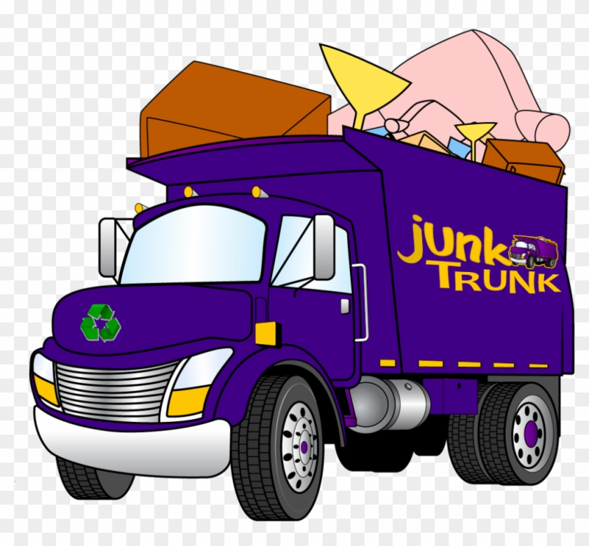
Watsontown Borough Residents
2023 Spring Clean-up Days
May 1st & May 2nd !!!

Each street will be covered only ONCE. All items must be placed at the CURB by 7 am on Monday, May 1st. The entire town will be collected on Monday, May 1st, leaving Tuesday, May 2nd for anything not collected on Monday. The Public Works Department expects to be completely done by 10 am on Tuesday morning.

NO collections in the alleys. ALL items must be boxed, bagged or placed in containers and may NOT weigh more than 50 pounds. Paint and roof cement cans or similar items will only be accepted if they contain NO LIQUIDS (all lids must be loose).

THE FOLLOWING ITEMS WILL NOT BE ACCEPTED: Building materials, batteries, grass clippings, chemicals, spoiled foodstuff, garbage, flammable materials, metal/plastic barrels, burn barrels, mattresses, motor oil, tires, plaster, blocks and bricks. The Covered Device Recycling Act also prohibits the disposal of computers, mice, televisions, laptops, printers, notebooks, computer monitors, keyboards and any other device that provides input or output from the computer.

REGULATIONS PROHIBIT THE FOLLOWING ITEMS: Computers, refrigerators, freezers and air conditioners or ANY item that may contain FREON. The Borough reserves the right to REJECT any and all of these items. The property owner will then be responsible for their immediate disposal. The Borough reserves the right NOT to collect any excessive amounts from any one property, (excessive is more than one pickup load). This is a benefit to all Borough residents. Please adhere to the rules listed above so the Borough may continue to offer this valuable service in the future.

